ed
BSC KOONS of SILVER SPRING PREMIER CUP
CHECK-IN INSTRUCTIONS

ON-LINE CHECK-IN:
- Team check-in due by:
Youth Premier Cup Weekend (U9 - U12): April 8, 2022 (Friday)

All teams that have successfully checked in on-line will have their stamped roster emailed back from GotSport. Please see the next sections on how to access the document upload site in GotSports.

NOTE: For any issues, please contact your Age Group Coordinator.

How to access GotSports:

- Login to GotSports using Team credentials
GotSport (https://system.gotsorts.com)

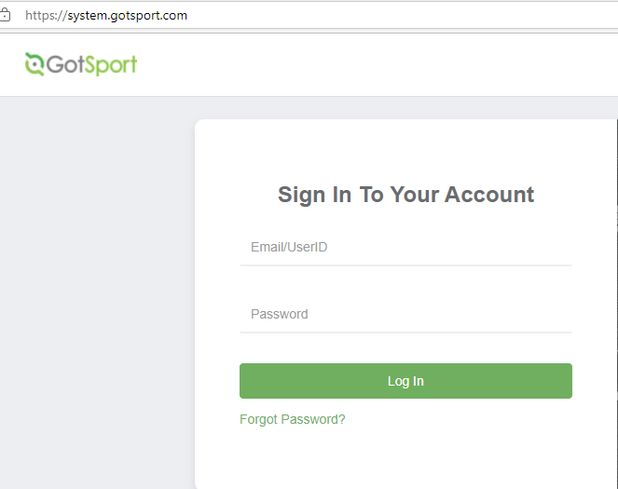

- Select “Scheduling” and “Events” to access “Bethesda Premier Cup Boys/Girls Youth 2022”

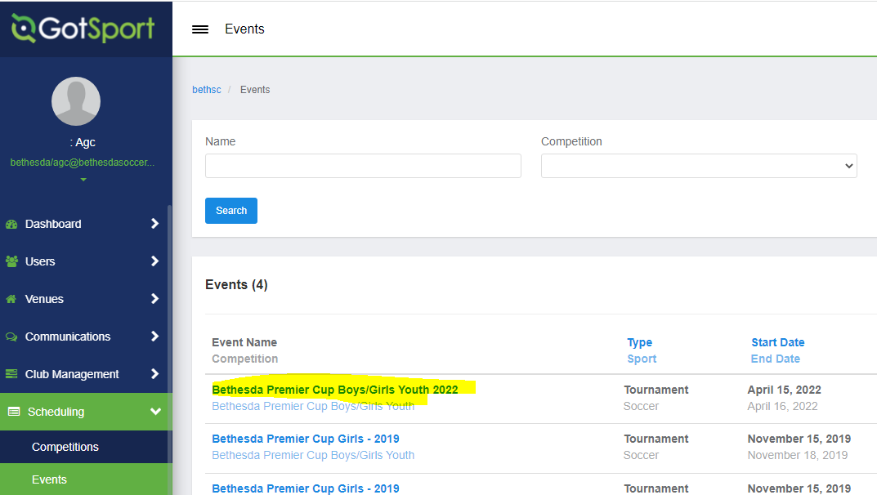

- Navigate to your “Team Registration” page under the “Event” and click on the “Registration” tab that will list the required online check-in documents as well as BSC USE only Approved On-Line Roster that will be returned when your team is checked-in. However due to a permission issue with GotSport, the event BSC USE only Approved On-Line Roster will be emailed back to the coaches and manager.

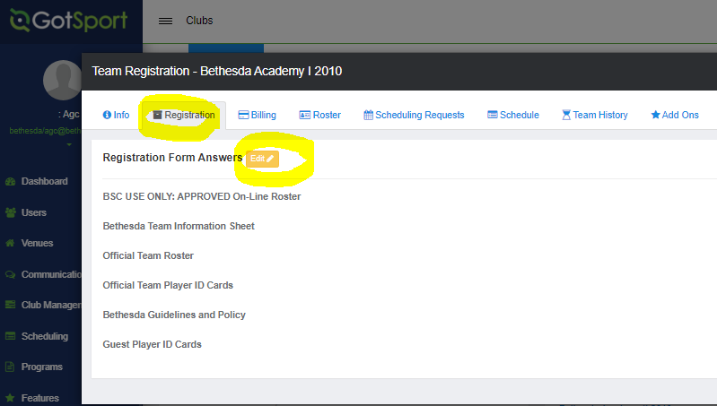

- Click on the “Edit” button next to “Registration Form Answers” to access the document upload link
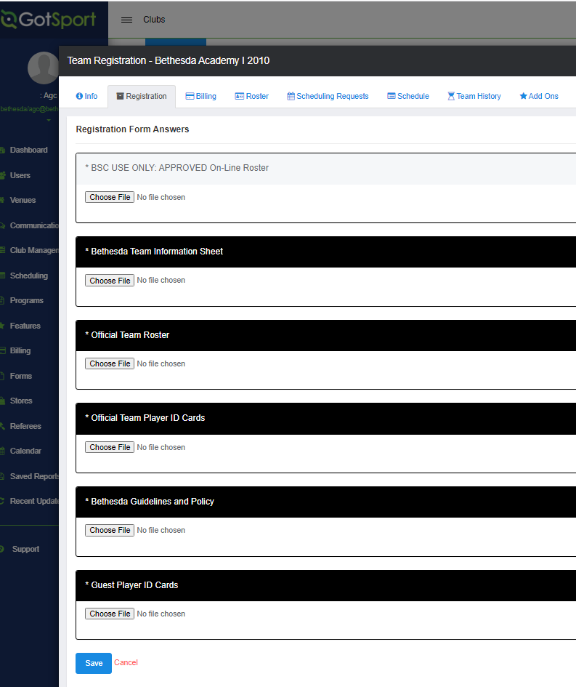

Required Documents for Online Check-in:
  - Signed “BSC Premier Cup Team Information Sheet.” The blank form can be found on the BSC Tournament Website under the team check-in tab.

- Official Team Roster issued by the US Club Soccer association or US Youth Soccer Association
(US Club Soccer Association)

(Example State US Youth Soccer Association)

- Official Team Player ID Cards or Passes issued by the US Club Soccer association or US Youth Association

- Upload the signed “BSC Guidelines and Policy.” The blank form can be found on the BSC Tournament Website under the team check-in tab.

- If guest players are required , write in the names of players to the team roster and upload and guest players US Club Player Passes.

Note: US Youth Soccer Teams outside of Region 1 or from NJ need to provide a signed permission to travel form. Check with your State association for the appropriate form. (Region 1 teams include: ME, NH, VT, MA, RI, PAE, PAW, NYE, NYW, CT, MD, DE, VA, WV)

FREQUENTLY ASKED QUESTIONS

Check -In Confirmation:

If I checked my team in on-line, how will I know my roster has been approved?
Approved stamped rosters will be upload back under the “BSC USE ONLY: APPROVED On-Line Roster” in the GotSports page above. This will be your official tournament roster. You MUST bring this to the tournament with you and show it along with your original player cards to every game.

Players not attending the event:

If a player is not attending the event do I leave their name on the roster?
No, if a player is not attending the event; you need to cross their name off of the roster.
Guest Players & Roster Size:

What is the maximum number of guest players a team can bring to the event?
A max of three (3) guest players will be allowed – this requirement has been waved for the spring tournament. Make sure that to mean the maximum roster size including guest players.

The following are the maximum roster size per age groups:
U09 – U10 (7v7) – 14 players
U11 – U12 (9v9) – 16 players
U13 (11v11) – 18 players
U14 - U19 (11v11) - 22 Players, but only 18 may dress for any given game.

How do I add a guest player?
Step 1: Obtain the guest players current player card and medical release form

Step 2: Photocopy your original roster – this has been waved for the spring tournament. Handwrite the guest player’s full name, unique jersey number, player identification number and birthday below the bottom of the existing rostered players.
Note: US Club Soccer teams may only take guest players registered under US Club Soccer, and USYSA teams may only take guest players registered with properly stamped USYSA player pass cards. No roster may be comprised of players with different passes from different organizations (no “mixed rosters”).

How do I add a guest player after my on-line registration was approved?
Due to the size of the tournament, teams will not be allowed to resubmit their roster online unless permission is given by the registrar. This will depend on the workload of the registrar. Teams will be allowed to resubmit their roster in person during the on-site check-in dates and times. If your team needs to modify/resubmit their roster you must do so before the deadline or follow the directions for on-site check-in.

Medical Release Forms

Do I include the medical release forms in the early registration document?
- No. All teams must have a medical release form for each player (including guest players) but DO NOT include the medical release forms in the online registration package.

Do Medical Releases need to be notarized?
- No. Medical Releases DO NOT need to be notarized. However, you must have signed our rules and guideline form stating that you have medical releases for all of your players.

Age Group Structure
What Birth Years play in each age group?
(Remember, players may play up but they cannot play at an age group younger than their birth year, i.e., a player born in 2004 may play U18 or U19/20. They may not play U17.)

2003 – U19/20
2004 – U18
2005 – U17
2006 – U16
2007 – U15
2008 – U14
2009 – U13
2010 – U12
2011 – U11
2012 – U10
2013 – U9

ALL QUESTIONS ABOUT ONLINE CHECK-IN CAN BE EMAILED DIRECLTY TO Bethesda Soccer at checkin@bethesdasoccer.org

